TATA CARA PENYAMPAIAN ADUAN MASYARAKAT

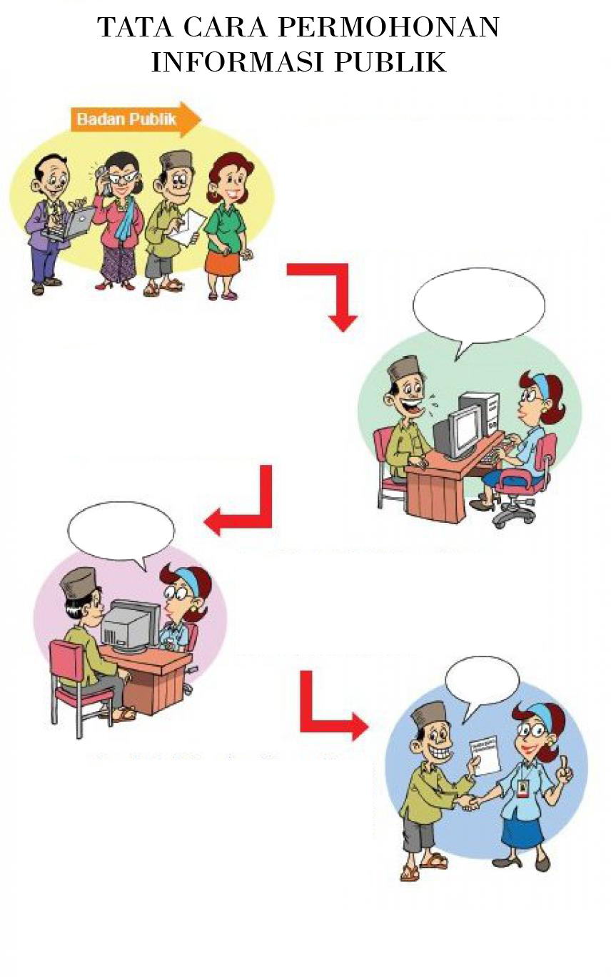

Langkah 1. Masyarakat menyampaikan aduan permasalahannya dengan cara datang langsung ke Dinas Pendidikan dan Kebudayaan Kota Magelang, secara lisan, maupun melalui surat, email, media sosial maupun melalui telephone.

Saya ingin menyampaikan aduan masalah pungli

Langkah 2. Masyarakat yang menyampaikan aduan harus menyampaikan data meliputi : nama, alamat, no identitas (copy KTP) no telephone yg bisa dihubungi serta jenis tanggapan yang diminta serta cara penyampaian tanggapan yang diinginkan

Saya catat dulu pak aduannya
Langkah 3. Pejabat penanganan aduan masyarakat mencatat semua informasi dan aduan yang disampaikan oleh pengadu. Menelaah data dan mengkaji kebijakan yang diadukan, melakukan konfirmasi unit yang diadukan dengan cara memanggil personal unit bersangkutan dan menyusun jawaban / tanggapan

Jangan lupa tanggapannya

Langkah 4. Pengadu harus meminta bukti penyampaian aduan kepada petugas yang melayaninya bahwa telah menyampaikan aduan permasalahan serta meminta nomor bukti pengaduan

PEMERINTAH KOTA MAGELANG
DINAS PENDIDIKAN DAN KEBUDAYAAN
Jln.Alibasah Sentot Prawirodirjo No. 6 (0293 ) 368529
e-mail : diknas_kota_magelang@yahoo.co.id

FORMULIR PERMOHONAN INFORMASI

No. Pendaftaran : .........................................

Nama | : | ..........................................................................................................
Alamat | : | ..........................................................................................................
 | : | ..........................................................................................................
Pekerjaan | : | ..........................................................................................................
Nomor Telepon/E-Mail | : | ..........................................................................................................
Rincian Informasi yang dibutuhkan | : | ..........................................................................................................
(tambahkan kertas bilaperlu) | : | ..........................................................................................................
 | : | ..........................................................................................................
Tujuan Penggunaan Informasi | : | ..........................................................................................................
 | : | ..........................................................................................................
Cara Memperoleh Informasi | : | 1. |  | Melihat/Membaca/Mendengarkan/Mencatat
 |  | 2. |  | Mendapatkan Salinan informasi(hardcopy/softcopy)
Cara mendapatkan Salinan Informasi** | : | 1. |  | Mengambil Langsung
 |  | 2. |  | Kurir
 |  | 3. |  | Pos
 |  | 4. |  | Faksimili
 |  | 5. |  | E-mail

Magelang, .............................

Petugas Pelayanan Informasi Pemohon Informasi

(Penerima Permohonan)

(.............................................) (...............................................)

PEMERINTAH KOTA MAGELANG
DINAS PENDIDIKAN DAN KEBUDAYAAN
JJln.Alibasah Sentot Prawirodirjo No. 6 (0293 ) 368529
e-mail : diknas_kota_magelang@yahoo.co.id

FORMULIR PERMOHONAN INFORMASI

No. Pendaftaran : .........................................

Nama | : | ..........................................................................................................
Alamat | : | ..........................................................................................................
 | : | ..........................................................................................................
Pekerjaan | : | ..........................................................................................................
Nomor Telepon/E-Mail | : | ..........................................................................................................
Rincian Informasi yang dibutuhkan | : | ..........................................................................................................
(tambahkan kertas bila perlu) | : | ..........................................................................................................
 | : | ..........................................................................................................
Tujuan Penggunaan Informasi | : | ..........................................................................................................
 | : | ..........................................................................................................
Cara Memperoleh Informasi | : | 1. |  | Melihat/Membaca/Mendengarkan/Mencatat
 |  | 2. |  | MendapatkanSalinaninformasi(hardcopy/softcopy)
Cara mendapatkan Salinan Informasi** | : | 1. |  | Mengambil Langsung
 |  | 2. |  | Kurir
 |  | 3. |  | Pos
 |  | 4. |  | Faksimili
 |  | 5. |  | E-mail

Magelang, .............................

Petugas Pelayanan Informasi Pemohon Informasi

(Penerima Permohonan)

(.............................................) (...............................................)

