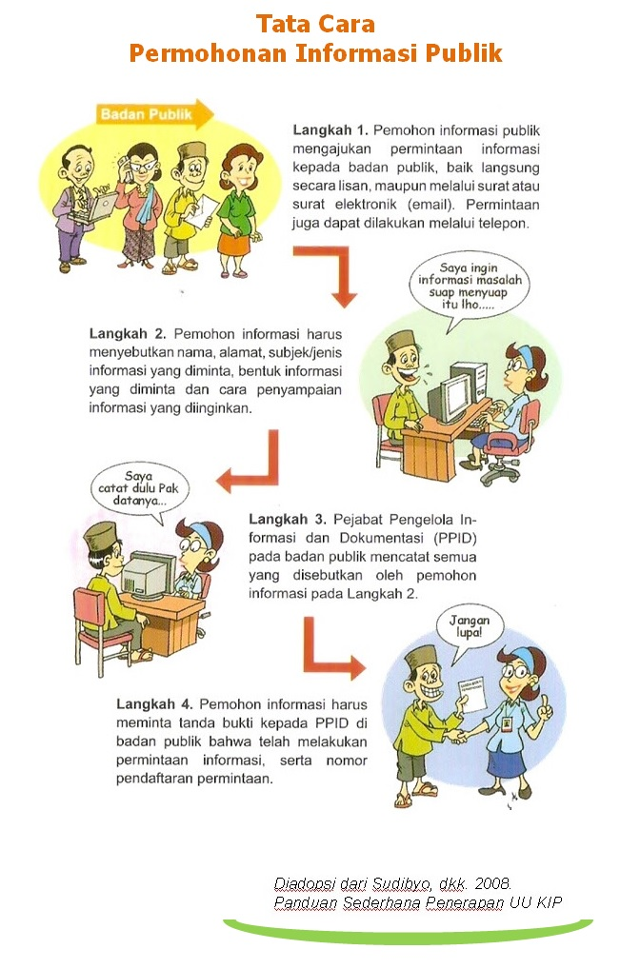

PEMERINTAH KOTA MAGELANG
DINAS PENDIDIKAN DAN KEBUDAYAAN
Jln.Alibasah Sentot Prawirodirjo No. 6 (0293 ) 368529
e-mail : diknas_kota_magelang@yahoo.co.id

FORMULIR PERMOHONAN INFORMASI

No. Pendaftaran : .........................................

Nama | : | ..........................................................................................................
Alamat | : | ..........................................................................................................
 | : | ..........................................................................................................
Pekerjaan | : | ..........................................................................................................
Nomor Telepon/E-Mail | : | ..........................................................................................................
Rincian Informasi yang dibutuhkan | : | ..........................................................................................................
(tambahkan kertas bilaperlu) | : | ..........................................................................................................
 | : | ..........................................................................................................
Tujuan Penggunaan Informasi | : | ..........................................................................................................
 | : | ..........................................................................................................
Cara Memperoleh Informasi | : | 1. |  | Melihat/Membaca/Mendengarkan/Mencatat
 |  | 2. |  | Mendapatkan Salinan informasi(hardcopy/softcopy)
Cara mendapatkan Salinan Informasi** | : | 1. |  | Mengambil Langsung
 |  | 2. |  | Kurir
 |  | 3. |  | Pos
 |  | 4. |  | Faksimili
 |  | 5. |  | E-mail

Magelang, .............................

Petugas Pelayanan Informasi Pemohon Informasi

(Penerima Permohonan)

(.............................................) (...............................................)

PEMERINTAH KOTA MAGELANG
DINAS PENDIDIKAN DAN KEBUDAYAAN
JJln.Alibasah Sentot Prawirodirjo No. 6 (0293 ) 368529
e-mail : diknas_kota_magelang@yahoo.co.id

FORMULIR PERMOHONAN INFORMASI

No. Pendaftaran : .........................................

Nama | : | ..........................................................................................................
Alamat | : | ..........................................................................................................
 | : | ..........................................................................................................
Pekerjaan | : | ..........................................................................................................
Nomor Telepon/E-Mail | : | ..........................................................................................................
Rincian Informasi yang dibutuhkan | : | ..........................................................................................................
(tambahkan kertas bila perlu) | : | ..........................................................................................................
 | : | ..........................................................................................................
Tujuan Penggunaan Informasi | : | ..........................................................................................................
 | : | ..........................................................................................................
Cara Memperoleh Informasi | : | 1. |  | Melihat/Membaca/Mendengarkan/Mencatat
 |  | 2. |  | MendapatkanSalinaninformasi(hardcopy/softcopy)
Cara mendapatkan Salinan Informasi** | : | 1. |  | Mengambil Langsung
 |  | 2. |  | Kurir
 |  | 3. |  | Pos
 |  | 4. |  | Faksimili
 |  | 5. |  | E-mail

Magelang, .............................

Petugas Pelayanan Informasi Pemohon Informasi

(Penerima Permohonan)

(.............................................) (...............................................)

